- Watch the video and write notes.
Ans noted the important points and written down
- Create a GitHub account. ?
Objective:
Enable Multi-Factor Authentication (MFA) for the GitHub account using a mobile authenticator
application.
Purpose:
To improve GitHub account security by requiring an additional authentication code along with the
password.
Implementation:
1. Logged in to the GitHub account.
2. Opened Settings from the GitHub profile menu.
3. Navigated to Password and authentication.
4. Selected the option to enable Two-Factor Authentication (2FA).
5. Selected the Authenticator App method.
6. Installed an authenticator application on the mobile phone.
7. Scanned the QR code provided by GitHub using the authenticator app.
8. Entered the verification code generated by the mobile authenticator.
9. Completed the MFA setup and verification.
10. Saved the recovery codes securely.
11. Logged out and logged in again to verify MFA authentication

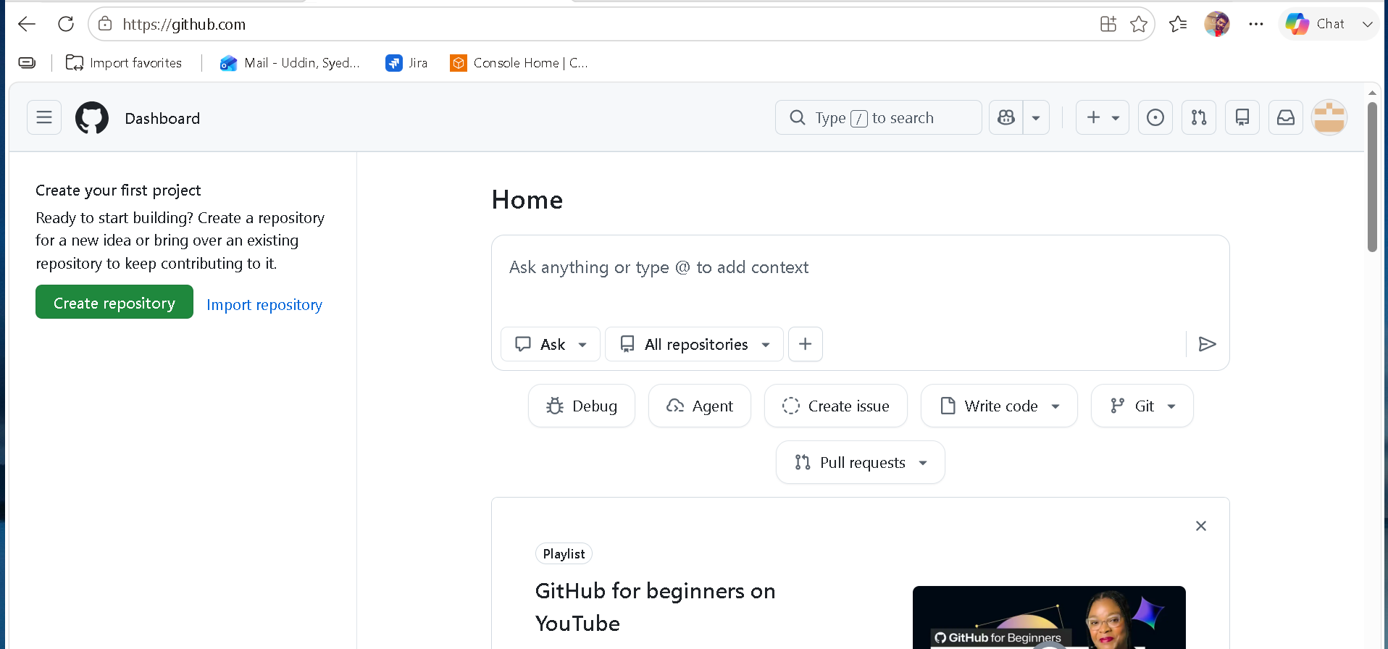

- Set up MFA (Multi-Factor Authentication) for the GitHub account using a mobile app.
To set up Multi-Factor Authentication (MFA/2FA) on GitHub using a mobile authenticator app (such as Google Authenticator, Microsoft Authenticator, 1Password, or Authy), follow these steps:
Prerequisite: Download a TOTP (Time-based One-Time Password) authenticator app on your phone from the App Store or Google Play Store.
Step 1: Open GitHub Security Settings
- Log in to GitHub.com.
- Click your Profile Picture in the top-right corner and select Settings.
- In the left navigation sidebar under the Access section, click Password and authentication.
Step 2: Enable Two-Factor Authentication
- Scroll down to the Two-factor authentication section and click Enable two-factor authentication.
- Complete the CAPTCHA prompt if GitHub asks for verification.
Step 3: Scan the QR Code
- Open your mobile authenticator app.
- Select the option to Add an Account (usually a + icon) and choose Scan QR Code.
- Scan the QR code displayed on the GitHub screen.
(If your phone camera cannot scan it, click setup key on GitHub to view a secret key and manually enter it into your app).
Step 4: Verify the 6-Digit Code
- Your app will generate a 6-digit dynamic code for GitHub.
- Type this 6-digit code into the Verify the code from the app field on GitHub.
Step 5: Download and Save Recovery Codes
- GitHub will generate a list of single-use Recovery Codes.
- Click Download, Copy, or Print to save these codes in a secure location (e.g., a password manager).
- Click I have saved my recovery codes to finalize the setup.
Important: Keep your recovery codes safe. If you lose your mobile phone, recovery codes are the only way to log back into your GitHub account.

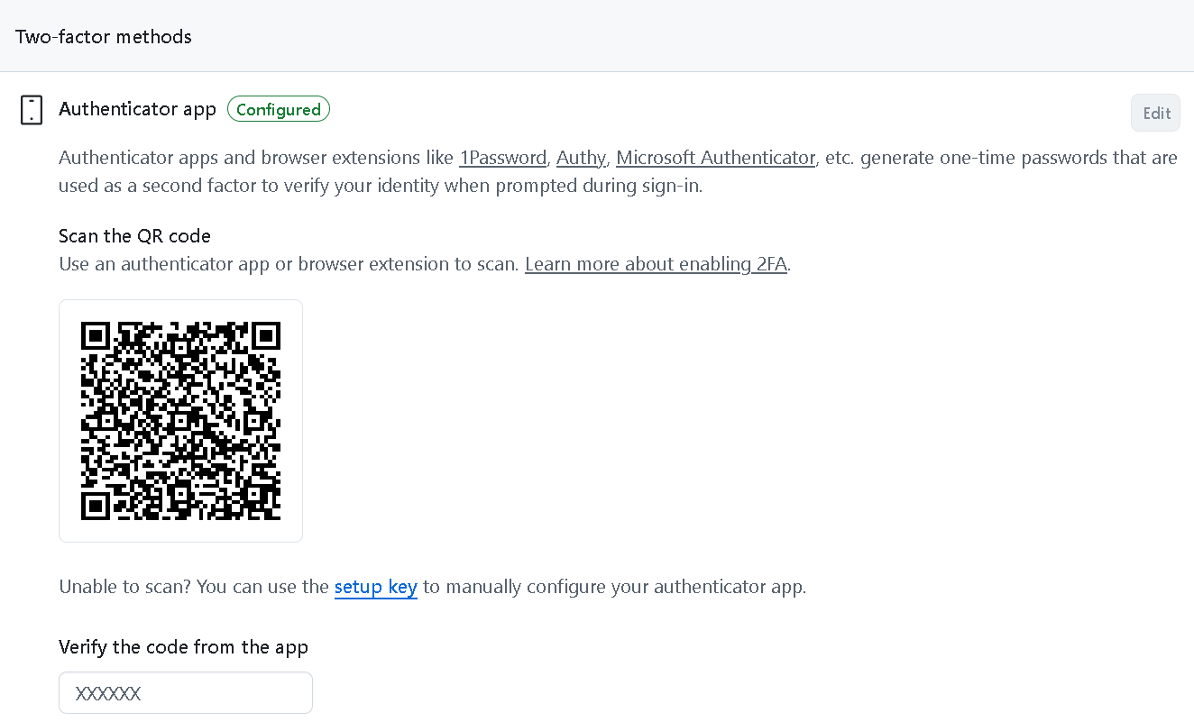

- Execute all commands shown in the video.
1 Install git hub
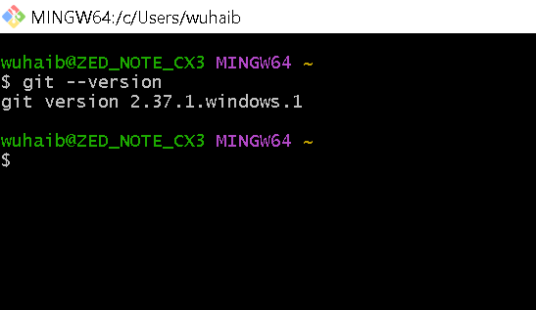
2 git status ?
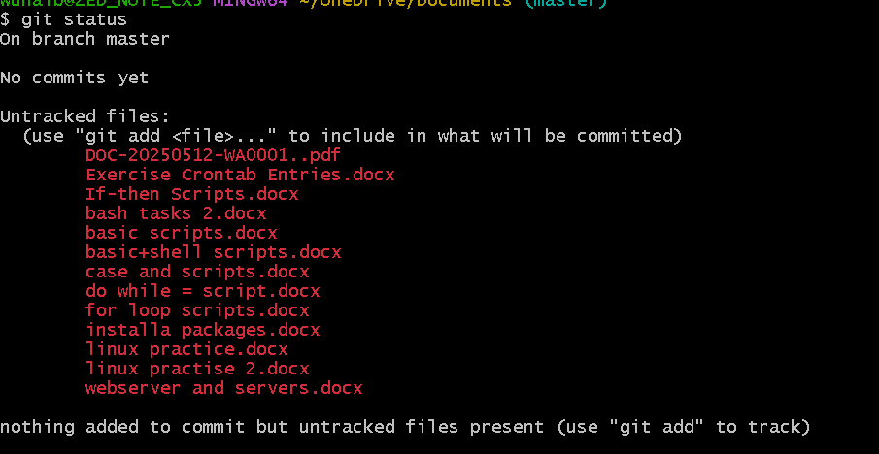
3 ) Git in it

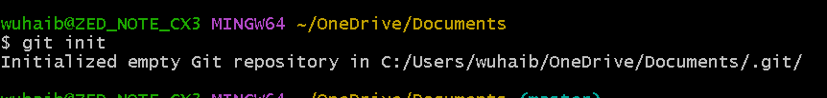
4 list for git
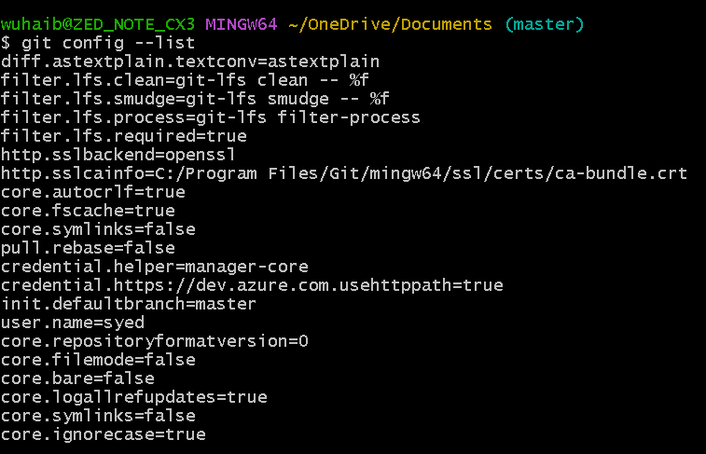

- Add username & email id ?
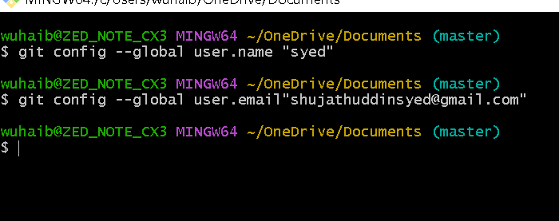
6 add files to track;s ?

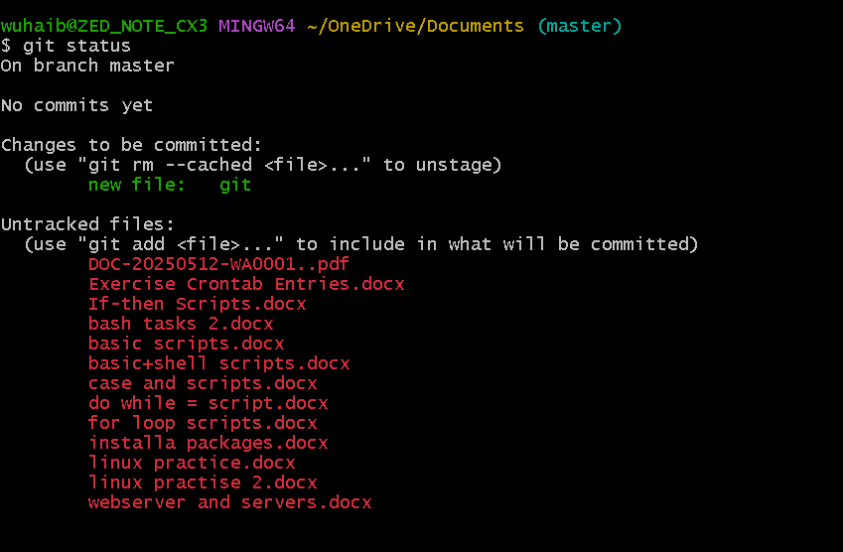

7 Track all the files in local machine ?
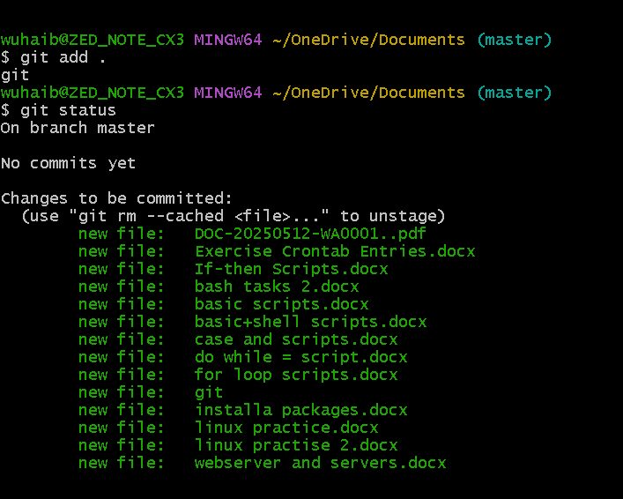

08 add user to git ?
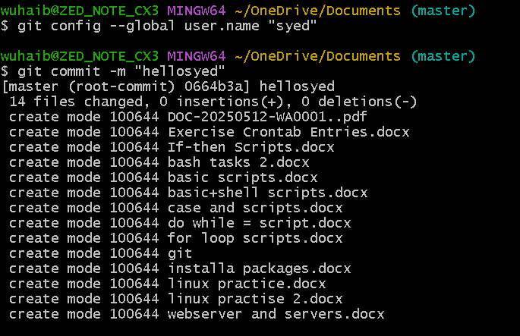

9 to find all the changes made in git ?
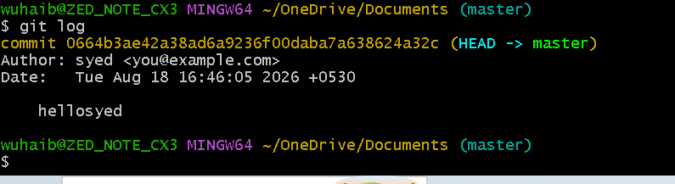

10\ to check the address of git hub ?
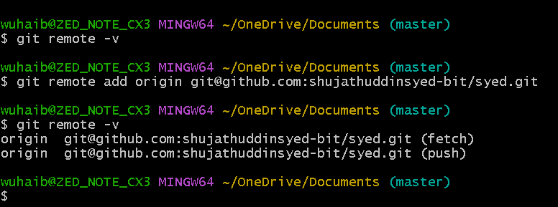

11} generate ssh key for connectivity ?
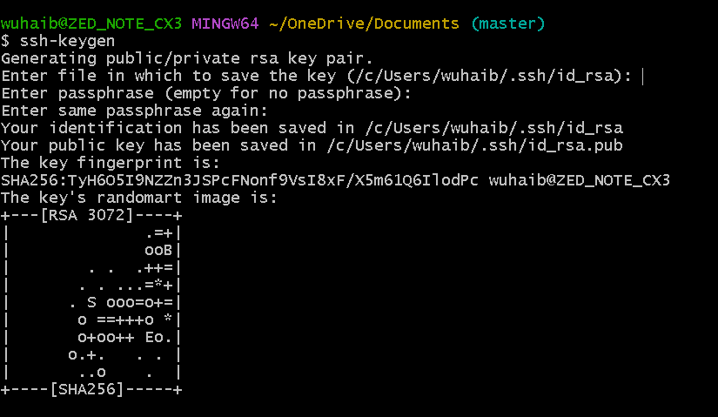

12 connect to github using ssh key ?
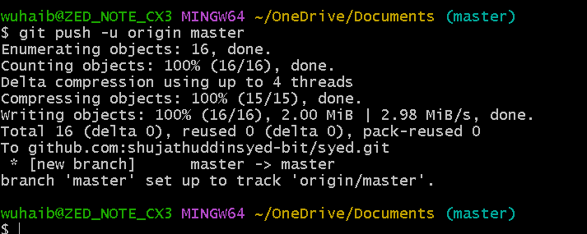
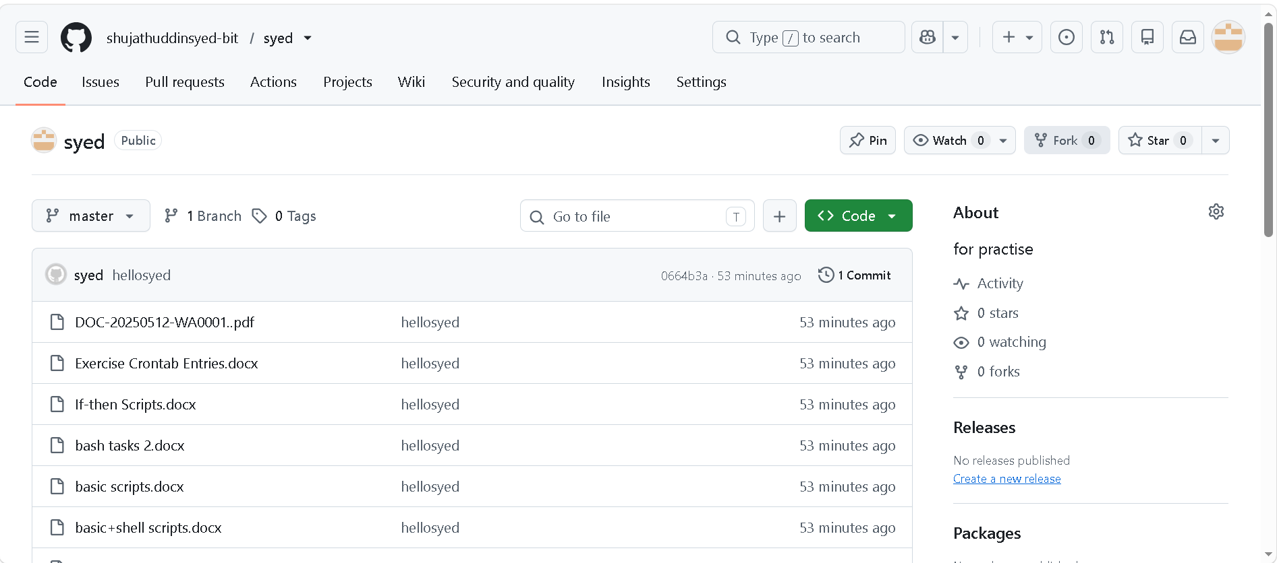

13* to pull up all the recent updated data ?


14 to recover the last deleted file ?
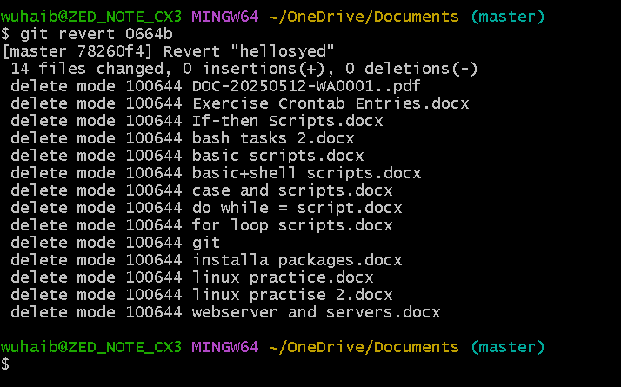

15 ] how to untracked to tracking file ?
